IPWEA Capital Project Award – February 2012

Project Name: Pakenham Library / Hall / U3A

Project Summary:

The development of the Pakenham Library / Hall / U3A facility was at a perfect time to take advantage of funding by the Federal and State Governments for a facility that incorporated Pakenham’s new Library and Hall and also provided a new home for the University of the Third Age (U3A). The existing facilities were not adequate for the rapidly growing community. Separate grant funding also allowed for the upgrade of the RSL memorial and the delivery of some of the best disability access facilities in Melbourne’s South-East.

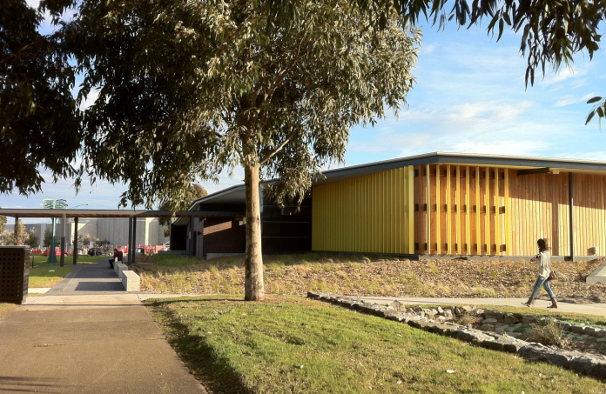

Project Description:

- Project Objectives – The project allowed council to consider several issues which were of concern to the Pakenham community and which council have as standard inclusions within its new building constructions. These were:

  - Provide a new library for Pakenham - The size of the existing library was not meeting the needs of the community and needed modernisation and an increase in space;

  - Replace the existing Pakenham Public Hall – The existing hall was 50 years old, under utilised and no longer could provide the options required for the fast growing Pakenham area such as heating /cooling, audio visual, security, ‘access for all’ and adequate car parking;

  - Provide a long term home for the University of the Third Age – the group were providing a valuable service to the community from an old sub standard house. U3A needed to expand with modern facilities and improved services and visibility;

  - Refurbish the existing RSL monument – The existing monument required refurbishment, provision of additional space for past fallen, and a greater prominence in its existing location;

  - Provide additional car parking – There was insufficient parking available and much of this was a crushed rock surface with no lighting;

  - Provide public art to the new facility – Council requires the provision of public art to its community facilities which cost more than $2 million dollars;

  - Ensure the requirements of council’s disability accessibility guidelines are incorporated within the facility.

- Project outcomes – The project has very successfully met the needs of the community with all the project objectives being achieved. Council worked closely with representatives from the Casey – Cardinia Library Corporation, the Pakenham Hall Committee, RSL and the University of the Third Age to ensure the delivery of a building that meets their needs and those of the community for the foreseeable future.

New library for Pakenham – The new library comprises some 1200sqm of public library/staff space and has a design capacity of some 50,000 items on shelf. The building has plenty of natural light, with a good sense of space from the variety of ceiling heights. The materials used are modern and add a range of textures to the finish, but are deliberately chosen to remain contemporary and withstand heavy use. Furniture and furnishings have been selected to provide modern colours and finishes to the library – moving away from a traditional library ‘feel’. The public has commented on the sense of space and the open, light ambience in the building. The children’s area in particular has been very popular, allowing traditional activities and events within a space defined by flowing curves and modern furniture. The new branch incorporates increased computer internet access, and plenty of study space. The use of personal wifi devices has significantly increased as people make use of the flexible space. As libraries change their services into the future, we are confident that this building will be able to evolve and support those new services and demands.

Public response to the new library has been very positive. Monthly visits since opening have doubled, reaching over 20,000 per month. Loans are expected to reach 480,000 for the first year of operation, compared to previous annual loans of 304,000. Internet computer bookings have also doubled.

  - Public Hall – The incorporation of the new hall into the one facility has allowed efficiencies with car parking, mechanical equipment and operational costs. The hall size is the same as the original with a separate large community space able to be opened up to provide significant additional space for larger functions. Both rooms are fully served by the central commercial kitchen. The solid hardwood timber floor provides significant improvement to the old flooring and the huge storage space has been a bonus for tables, chairs, the portable stage and portable disability lift. Council has fully satisfied the Hall Committee’s expectations;

  - Home for the University of the Third Age – the new modern facilities of more than 200m2 comprises 4 training rooms, office and independent kitchen facilities. New touch screen computers and electronic white boards were included to improve access for the disabled and the elderly. U3A are very proud of their new facility with user numbers increasing significantly;

  - Refurbish the existing RSL monument – The large granite stone monument was carefully removed from site during construction and refurbished by an experienced stone mason. Additional wall space was provided for the future recording of local soldiers not returning from service. The RSL has been extremely happy with the upgrade and refurbishment.

  - Provide additional car parking – Additional angle parking was provided within the side street and allows quick entry to the facility. Lighting meeting the Australian Standards was added to the existing car parking and will allow safer access to vehicles at night after an event or following a late evening visit to the library.

  - Provide public art to the new facility – Following a request for submissions, the ‘Federation Bell Tree’ art feature was commissioned by council. Council's latest addition to its public art collection, the Federation Bell Tree, was unveiled at the building's opening. The tree is a sculptured eucalypt by artist Dr. Anton Hassell and stands 5.5 metres tall with 12 Federation harmonic handbells in its foliage. The tree will collect visitors and guide them towards the building's entrance; acting as both a symbol of the new library and its role as a meeting place.

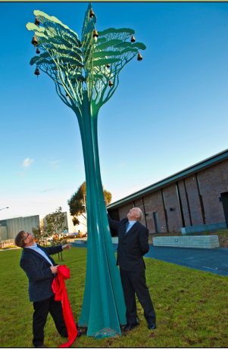

  - Ensure the requirements of council’s disability accessibility guidelines are incorporated within the facility – During design development, council received an additional $200,000 grant from DHS to provide increased accessibility to the site. This allowed the inclusion of a fully functional accessible toilet with hoist, portable lift for the hall stage, touch screen computers, electronic white boards, hearing augmentation, charge points for electric wheel chairs and scooters, colour and Braille way finders and automatic doors. A local organisation, Outlook which supports disability inclusion within the community, worked closely with council on these items and submitted the building for a National Award for disability inclusion.
DHS as the grant provider will use this facility as a leading example disability inclusion within community facilities.

- Innovative features of the project – Council has extensive experience in the delivery of public buildings and requires its buildings to be ‘interesting’, ‘functional’, ‘accessible’ and have ‘ESD credentials’.

  - The site chosen was difficult being on the corner of a busy roundabout and tightly constrained by an existing car park and side road. It is highly visible on all sides and required a design that considered these issues.

- The RSL memorial being closest to the intersection needed to appropriately fit its position at the ‘front’ of the building and its integration has transformed its significance within Pakenham. The rainwater harvesting has 3 tanks integrated into the building to supply rainwater to all the toilets. They are ‘hidden’ behind the yellow tiled columns but still provide a subtle presence to the passing community.

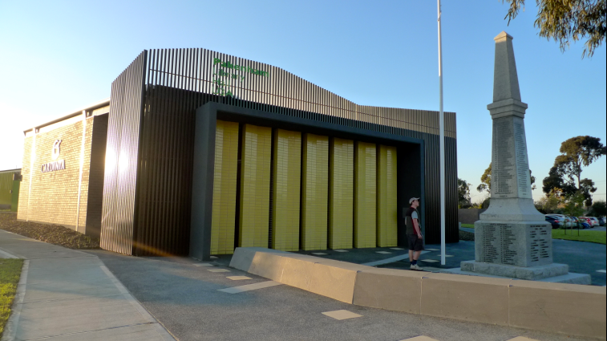

  - The library has northerly facing double glazed windows which provide significant natural light into the building. This north aspect overlooks a reserve and allows the library to be easily extended in the future.

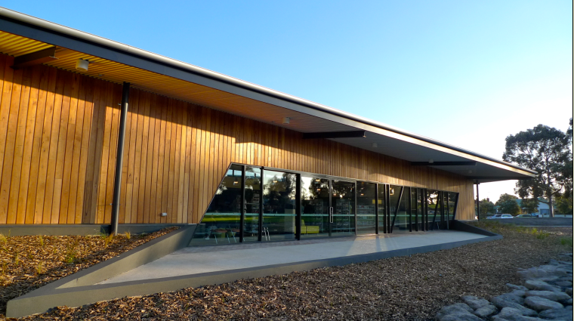

  - Access is provided to both the side street and from the car park. The building meets Australia’s Enhanced Accessibility Standard AS1428.2 for disability access. A ‘state of the art’ accessible toilet with hoist means more of the Pakenham community and travelling public with disabilities can visit the facility. This is one of the first of these toilets installed in the South – East growth corridor.

  - Solar hot water with ring main ensure hot water is readily available to all parts of the building.

- Distinguishing features of the project – In developing the project, the architect has balanced the use of natural timber, brickwork, tiles and bright highlight colours to deliver a unique visionary experience.

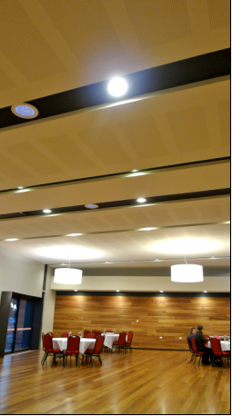

The colour scheme within the library is bright and light and has proved welcoming to the community and children in particular

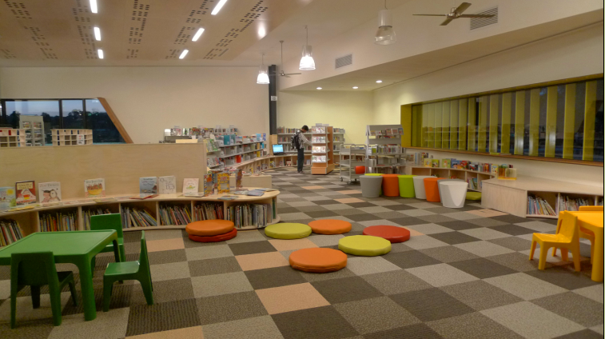

The yellow blades to the front windows and the bold green provide the visionary experience and a reduction in direct sunlight at varying times of the day.

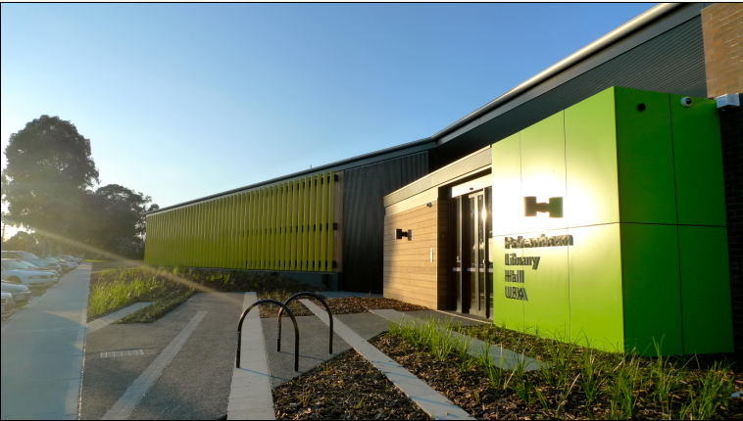

The yellow column tiles shown in a previous picture above provides an appropriate backdrop to the memorial and subtle external cover to the water tanks.

- Barriers overcome to achieve success – The project was affected by two significant barriers. These were:

- The Federal funding for the project required a tight timeline to complete the project. This meant the architect was given reduced timelines to complete the design by mid October 2009 to allow 4 weeks for tendering and council approval at the December council meeting. The architect, council and the community worked very closely to reduce delays during the concept design, functional layout and detail design development with hold point sign-off’s being given high priority. Construction was able to start immediately after the Christmas break.

- The construction was affected by the heavier than average rainfall during 2010 delaying the completion of the concrete slab. The concrete slab was constructed in 3 separate pours and the wet days and slippery site conditions caused significant delays. This contributed to the later than expected completion in April 2011.

- Cost/Benefits associated with the project – Council were given several external grants for the project worth more than $3.7M with the overall projects construction cost being $6.8M. This was $600,000 below council’s budget for the project. These grants significantly reduced the cost burden to council and the community. Without the grants, this integrated facility would probably not have been constructed.
The combining of existing facilities into the one integrated facility has provided significant benefits to the community. The community now have a modern facility that has reduced maintenance and operational costs.

General Comment’s 300 – 500 words

The construction of the Pakenham Library / Hall / U3A is a typical building construction project for Cardinia where architects are engaged to design with their team of consultants including mechanical, electrical, hydraulic, access and structural, a facility which meets the needs of the Cardinia Community. Cardinia utilized a Project Advisory Committee (PAC) for community consultation with representatives from each user group on the committee plus the ward councillors.

Once the Functional design is approved, the Project Construction Group (PCG) met regularly to monitor and advise on the design, delivery and ongoing maintenance of the project.
Regular detail design meetings were held with the architect and his consultants to ensure the design development and tender document preparation were achieved within the short time frame. It was important for the architect to understand several site design issues which council was able to internally support and expedite where appropriate. These included
- There was insufficient power to the site and a new transformer was required. Sub metering was required for the separate users;
- The existing sewerage connection point required deepening
- The landscape design required close consideration of the roundabout to ensure its operation was not compromised.
- Tree removal for the side street car parking required an arborist report.
- The Telstra underground cabling and the underground drainage pipe work required relocation to enable the side street car park to be constructed to the design levels

As part of the project delivery and Grant funding requirements, updated progress reports were required. Council established a close working relationship with these funding bodies.

The Buildings and Facilities Unit from council provided the superintendants representative for the project.

The State Government Minister for Local Government Jeanette Powell attended the official opening of the new $7.4 million Pakenham Library, Community Hall and University of the Third Age in Pakenham and made the following comments in her speech:
“Co-locating the library, with the community hall and the University of the Third Age will help draw the broader community together and increase community pride,” Mrs Powell said.
“The Pakenham Library and Community Hall is a wonderful space that will accommodate the needs of Cardinia Shire residents now and well into the future.
“We are proud to partner with the Commonwealth and Cardinia Shire Council who have made this dream a reality.”

Cardinia Shire Council Mayor, Cr. George Blenkhorn said the new building signified a new era of opportunities for the community.

"This state-of-the-art library, hall and U3A are an investment in Cardinia Shire's future and the facilities will benefit everyone. I encourage residents to visit and have a look at what's on offer"

Peter Carter, CEO of the Casey-Cardinia Library Corporation made these comments:

The new Pakenham Library, co-located with the U3A and Pakenham Hall, is an outstanding example of cooperation and shared community facilities.
Cardinia Shire is to be congratulated on the successful completion of this project. Best practice in public library location and design recommends the location of library branches with key community facilities, and the building achieves this excellently. The new building has a strong presence on the corner of Henry and John Streets, providing the community with a new landmark civic feature.

The Library Corporation was very pleased to work with the Cardinia Shire Council and Perkins Architects on this project. The suggestions and views of the library staff were considered in the design process, and this was appreciated. Both Council and the architects wanted a high quality, landmark civic building and have successfully achieved this.

