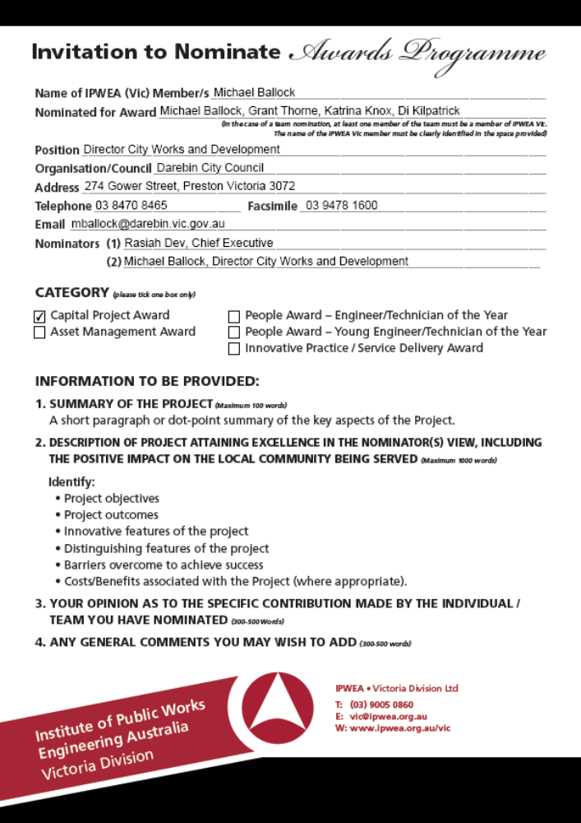

Name of IPWEA (Vic) Member/s: | Michael Ballock
Nominated for Award: | Michael Ballock, Grant Thorne, Katrina Knox, Di Kilpatrick
Position: | Director City Works and Development
Organisation/Council: | Darebin City Council
Address: | 274 Gower Street Preston
Telephone:  Facsimile: | 03 8470 8465  03 9478 1600
Email: | mballock@darebin.vic.gov.au
Nominators (1): | Rasiah Dev, Chief Executive
Nominators (2): | Michael Ballock, Director City Works & Development

CATEGORY: Capital Project Award

1. SUMMARY OF THE PROJECT
Institute of Public Works
In 2010 Council commenced the development of the Lancaster Gate Community Centre. This $6.1 million project involves the redevelopment of part of the former Larundel Psychiatric Hospital site, which was donated to Council by VicUrban.

The community centre is located within an area of the municipality which has experienced significant population growth (additional 6,000 residents over the last 5 years), with a high proportion of the growth being young families, students and older residents from CALD communities. The community centre provides the facility which will deliver community services and flexible spaces for community use.

The development of this community centre is a partnership between VicUrban, Department Regional Australia, Local Government, Arts and Sport, Darebin City Council and the community.

Victoria Division
2. DESCRIPTION OF PROJECT ATTAINING EXCELLENCE IN THE NOMINATOR(S) VIEW, INCLUDING THE POSITIVE IMPACT ON THE LOCAL COMMUNITY BEING SERVED

Project Objectives

The development of the Lancaster Gate Community Centre will provide the following core services for this growing community;

- Early years services (i.e. kindergarten, maternal child health and family support)
- Children’s learning and play activities (i.e. kinder garden, playgroup, occasional care, etc)
- Community health services (i.e. counselling)
- Group activities (programmed activities and room hire)
- Learning (i.e. education, training, library access, computer and internet access, etc)
- Recreation (i.e. arts and culture programs, leisure, passive and active play, picnic, etc)
- Events and functions (i.e. markets, room hire, etc)
- Corporate facilities

Project Outcomes

The project provides a hub for the provision of community services for a growing community within a sustainably redeveloped historic building.

Innovative and distinguishing features of the project

The project features the restoration of a portion of the former Larundel Psychiatric Hospital, which closed in the late 1990’s. The site is now under going development and a portion of the land and one building were donated to Council by VicUrban for the establishment of a community centre.

The redevelopment of this historic building features a number of innovative and distinguishing features. The Lancaste Gate community Centre has been developed with the aim to produce an ecologically sustainable building for general use within the community. The current design of the Lancaster Gate Community Centre achieves a theoretical 4.5 Star NABERS self assessment undertaken by WSP Lincoln Scott Pty Ltd.

The Lancaster Gate Community Centre aims to reduce the environmental impact by reducing the dependence on renewable resources such as fossil fuels and water. Best practice sustainability principles have been used throughout the design and construction of the new community centre to reduce impact on the environment. This includes photovoltaic solar cells, rainwater harvesting and reuse, eco-friendly building materials, recycled materials and waste management. A component of the design of the building was to have a minimum of 10% energy contribution from renewable energy generation onsite and a minimum 25% reduction in potable water demand. The heating, ventilation and air conditioning (HVAC) system is a mixed mode system. The system utilises the windows for natural ventilation when the weather is within a comfortable temperature range. Outside of this range, fan coil units and radiant heating panels provide heating and cooling to the spaces.

Barriers overcome to achieve success

Darebin is demographically diverse and steadily growing municipality with a high proportion of young families, students and older residents from CALD communities. Residential development in the north of Darebin has resulted in significant population growth.

There is a lack of community facilities in this growing residential area and there was limited opportunity on Council land, in the area, to develop a community centre to address the needs of the community.

To address the gap in service provision Council negotiated with VicUrban as part of the larger development that a portion of land and an existing building be donated to Council for the establishment of a community centre.

These negotiations were success, however the building was in a state of disrepair when officially donated to Council in March 2010. The building spaces required extensive redevelopment to meet the objective of providing community services.

To develop a project which met the needs of the community, Council formed a reference committee, with the community being invited to participate in the decision on the purposes, design and operation of the centre. Following a series of forums with the community, Council service units and community service organisations, a range of possible activities and uses were identified for the proposed community centre.
The following is a summary of the popular suggestions.
- Information and meeting place
- Early years services (i.e. maternal child health and family support)
- Children’s learning and play activities (i.e. playgroup, occasional care, etc)
- Community health services (i.e. counselling)
- Meeting and study spaces
- Group activities (programmed activities and room hire)
- Learning (i.e. education, training, library access, computer and internet access, etc)
- Recreation (i.e. arts and culture programs, leisure, passive and active play, picnic, etc)
- Amenities (kitchen, toilets and storage)
- Events and functions (i.e. markets, room hire, etc)
- Café / catering facilities
These suggestions correlate well with Council’s own information and assessment of services in demand in this growing community. Whilst some of these suggested activities and uses have not been included in this community centre, there is opportunity to strengthen access to other nearby community facilities that provide these activities or services.

3. YOUR OPINION AS TO THE SPECIFIC CONTRIBUTION MADE BY THE INDIVIDUAL / TEAM YOU HAVE NOMINATED

The Major Projects, Engineering and Transportation teams ability to engage a wide range of internal and external stakeholders and the amount of flexibility they demonstrated is highly commendable.

Consultation stakeholders included VicUrban, Department Regional Australia, Local Government, Arts and Sport, residents and the local community (through the Community Reference Committee), Councillors and Council staff and interested community organisations.

The team took on board the feedback from the community consultation and suggestions and input from stakeholders to produce a community centre which will provide a hub for community services in this growing community.

The Major Projects, Engineering and Transportation teams’ continuous desire for innovation and in raising the standard to achieve a best practice approach in the design phase has achieved a great outcome for the residents of Darebin.

4. ANY GENERAL COMMENTS YOU MAY WISH TO ADD

The redevelopment of the Lancaster Gate Community Centre has been a highly collaborative effort between the Federal Government, Department Regional Australia, Local Government, Arts and Sport, VicUrban, and the Darebin community. This highly regarded partnership approach will continue through the delivery of community services and flexible spaces offered to the community.
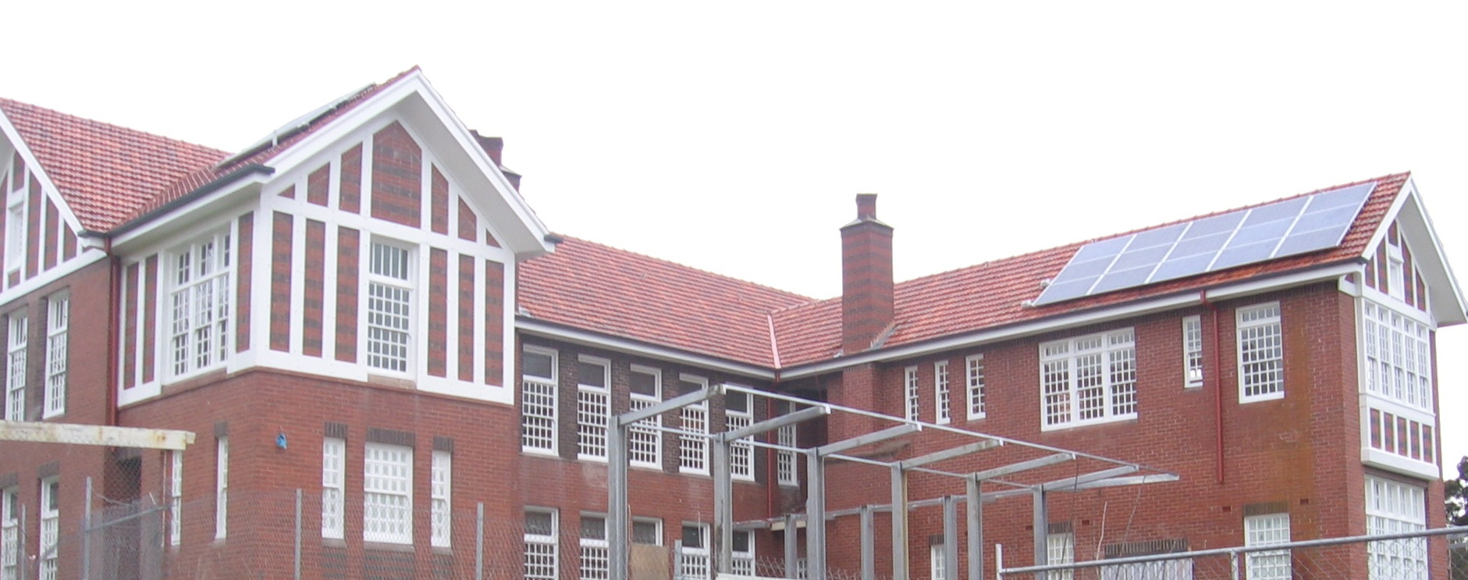
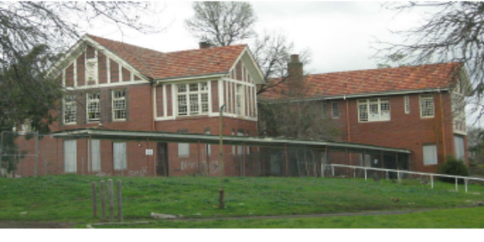
Before After

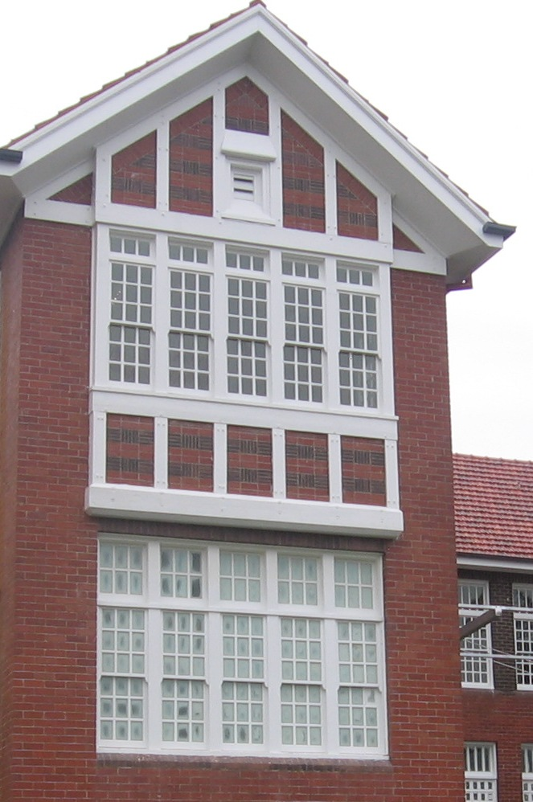
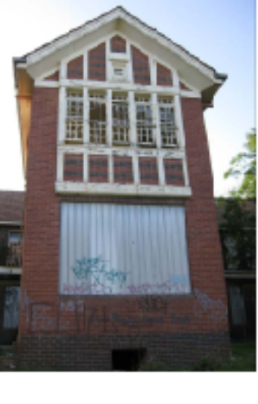

Before After
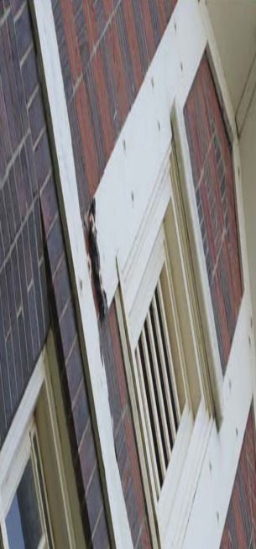

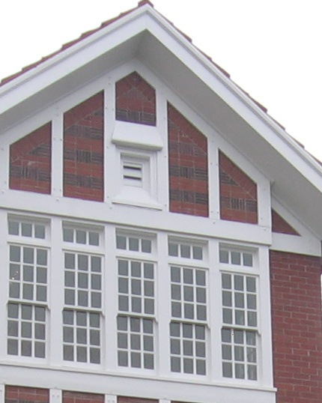

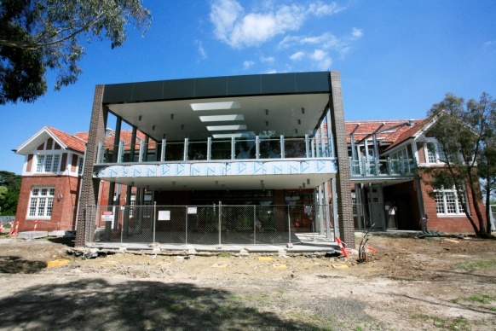
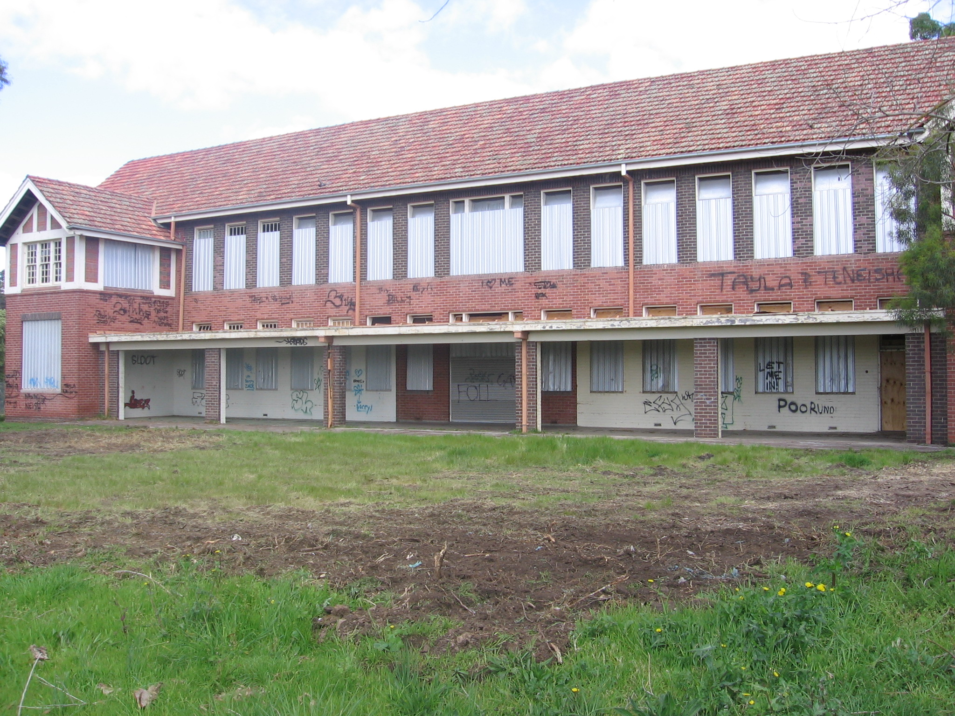
Before After

Terrace Terrace



